Department Of ECONOMICS
Faculty’s Profile
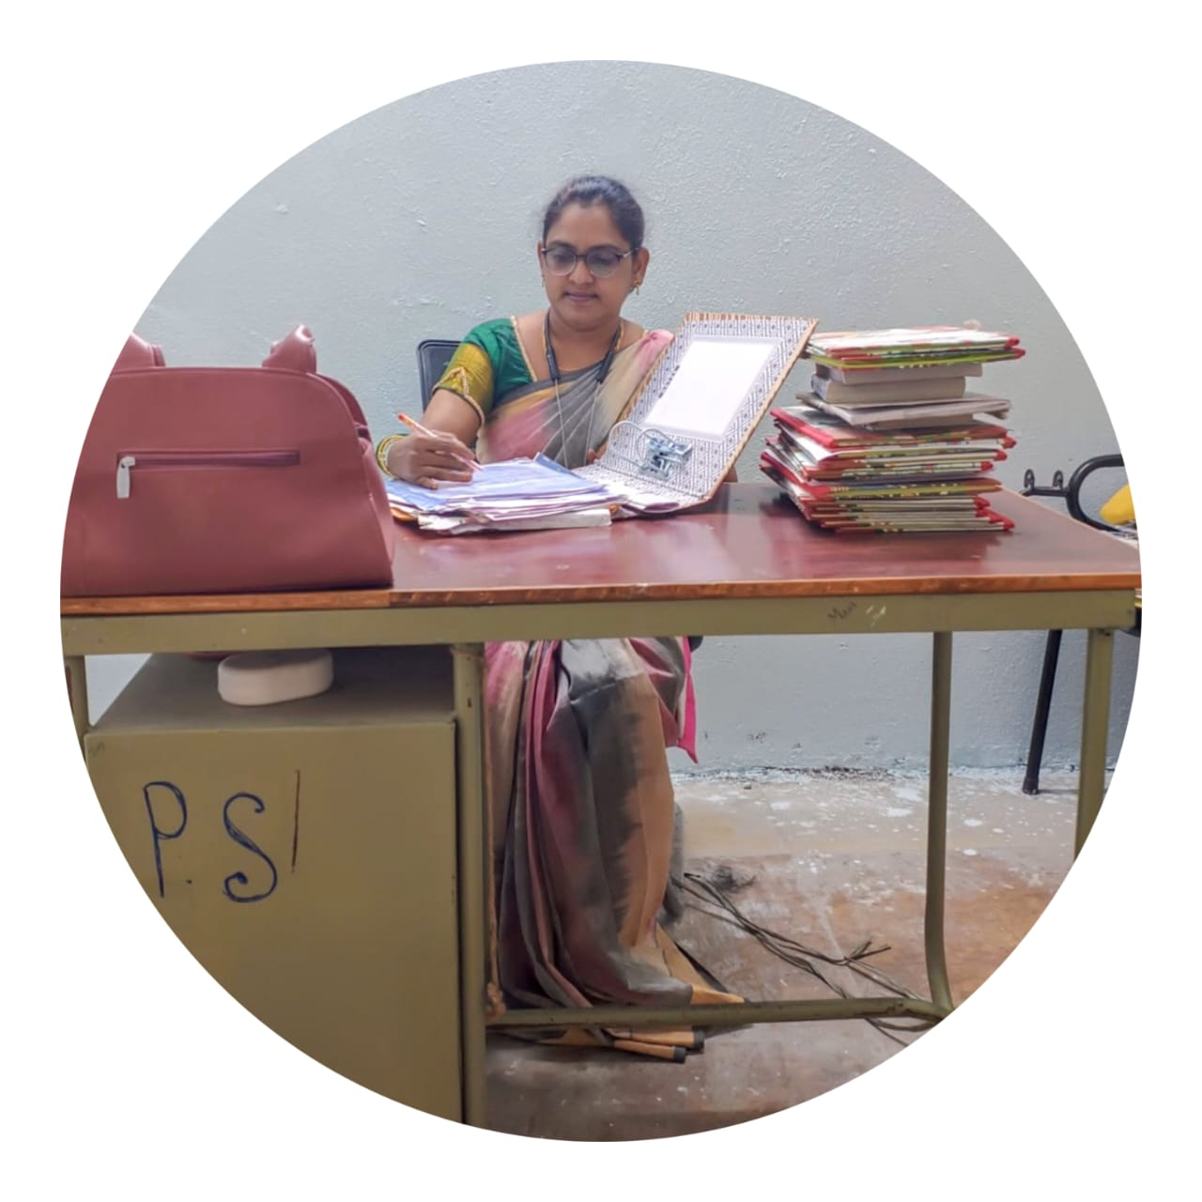
KOLLURU KALPANA
Degree Lecturer
Department of Economics
MJPTBCWRDC Women Station Ghanpur
☎:9963933956 , 📧 kalapanakolluru282@gmail.co
- Education Qualifications : M.A., B.Ed
- Teaching Experience : 1. I had worked as J.L.in Economics 16 years at
MPJC, TSWREIS.
2. I had worked as D.L for 1 Year at TTWRDC (G),
JANGAON.
Name of the Department: ECONOMICS Year of Establishment: 2023

Programs offered:
- B.A(H.E.P)

Pattern of teaching learning and evaluation:

Semester | Credit system
I,II,III,IV,V,VI | Choice based credit system  (CBCS).

About the Department
The department of Economics was established in the college in August, 2023. First department offered B.A (H.E.P) course in 2023 year. From 2023 year, it offered B.A (H.E.P) and B.A (H.E.P) courses in the department. The faculty always tries to enrich the students by adopting various teaching and learning methodologies. For the practical subjects our department organizes different guest lecturers of eminent personalities from professional fields. We have strong alumni who are presently working at different positions in reputed sectors like corporate, banks, business etc. we focus on overall development of our students and hence we encourage them to take part in various co- curricular and extracurricular activities like NSS,NCC, cultural events and also in various college level and university level competitions. We follow the practice of industrial and field visits for the students for practical and project work. For our average students we conduct remedial teaching and the progress of our students is observed through mentor and mentee. We conduct bridge course for the students who come from different streams for U.G B.A (H.E.P) course. Our department has prominent faculty with very good academic record. Our faculty always tries to enhance their knowledge by participating in various co-curricular activities like examination duties, attending syllabus restructuring seminars, workshops, national and international level seminars, NSS activities, E-content development etc.
ACTIVITY: DEBATE
TITLE OF THEDEBATE (Population growth Boon or Bane)
Date: 12-07-2025
Academic Year: 2025 - 2026
Organizing Department: Department of Economic
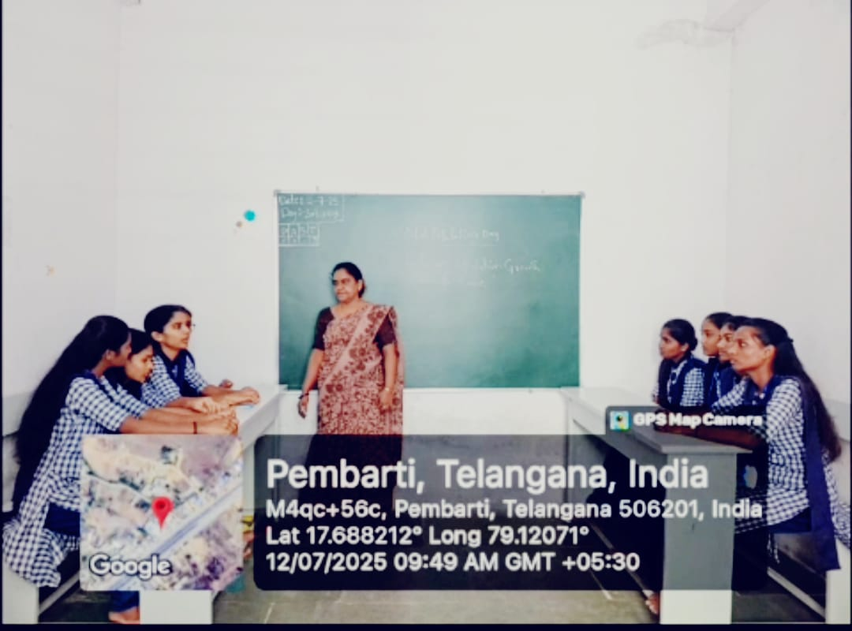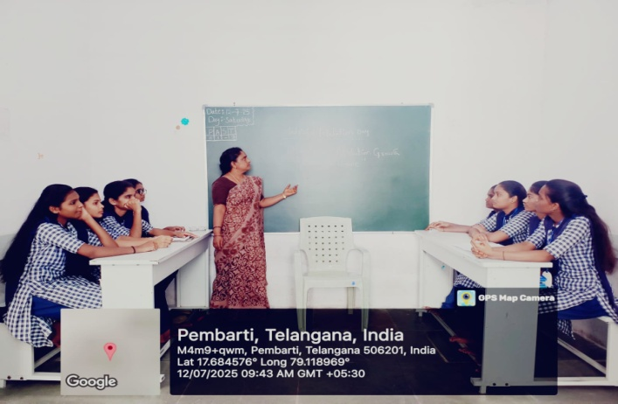

OBJECTIVES: Population growth can be boon or bane depending on how effectively a nation manages its resources and invests in its people.

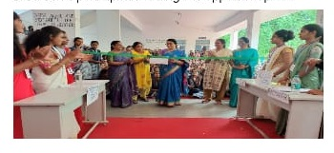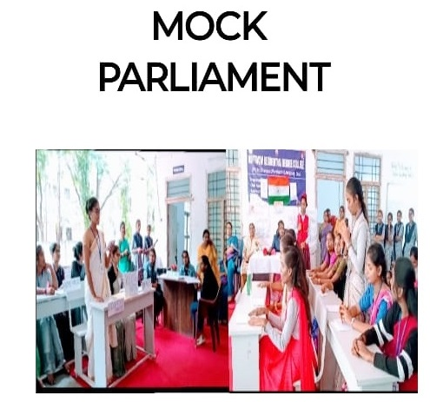

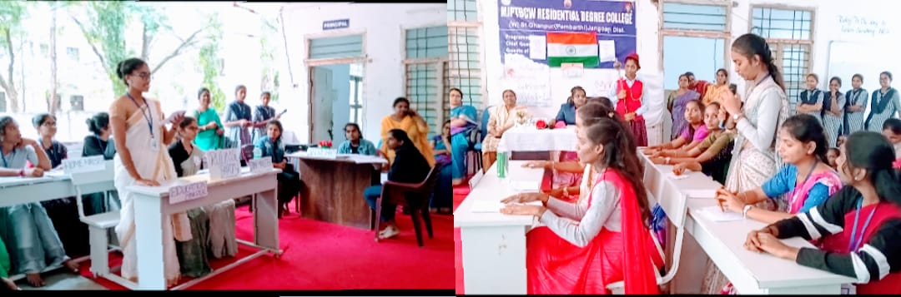

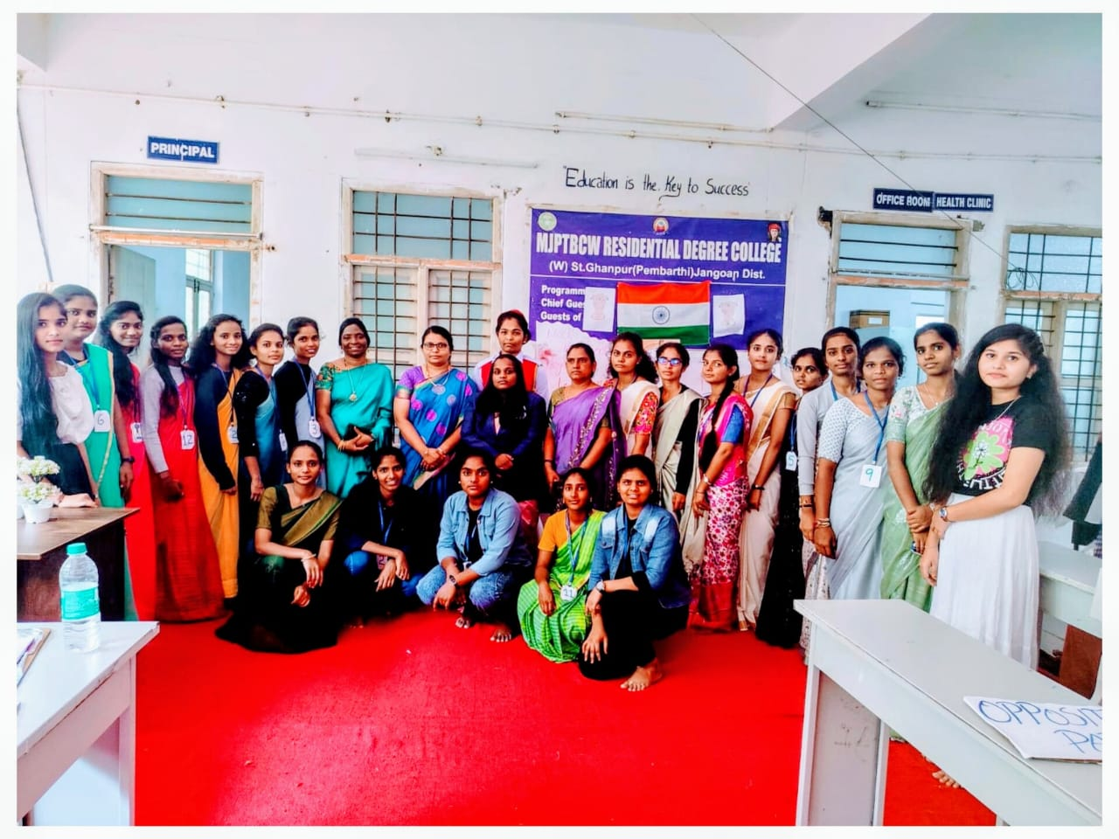

ACTIVITY: MOCKPARLIAMENT
Date: 24-07-2025
Academic Year: 2025 to 2026
Organizing Department: Department of Economic

OBJECTIVES:

Small awerencers programmed on mock parliament.

Disabused various departments’ matters like education financial home women & child welfare and agriculture defence etc.

Students participated as ruling and opposition parties.

OUTCOMES

Students also develop Leadership teamwork and critical thinking abilities through active participation in the simulated political environment.

VISION

  - Provide conductive environment for quality education in EconomicsEntre prenrship and research through innovative and healthy practice with commitment.
  - Commitment to pursue excellence in commerce education, while equipping students with knowledge and skills in Economics stream, inculcate values, identify hidden talents, provide opportunities for students to realize their full potential and thus shape them into national assets, and to pursue a real holistic development, integrity, moral and ethical uprightness.
  - The department is committed to integrate all facts of Economics and management to educate and train innovative and competent human resource globally suitable for industry, business and service sector and to equip and encourage them to start their own ventures in urban or rural areas benefitting both the classes and masses.
  - Inculcate ethical and moral values by offering a support system which is friendly and inspiring the future nation builders.

MISSION
- Department of Economics is dedicated to excellence in performance and committed to provide quality education opportunities and services that meet the needs of business and also contribute for the society’s wellbeing, national development and to meet global competencies.
- Creating healthy environment for teaching, learning and research activities.
- Generating and providing resources and facilities to the faculty and the students for generating innovative ideas.
- Creating an urge in students to take up entrepreneurship in order to be successful by being dependent on others.

OBJECTIVES
- To introduce students of economics to the global Market.
- To promote employability.
- o make them improve criticalthinking
- To create awareness among the students about the opportunities in higher studies like B.A (H.E.P)To stimulate social responsibilities through community oriented extension programmers.
- improve academic performance of the studentsTo create awareness among the students about the opportunities in higher studies like B.A (H.E.P)
- To stimulate social responsibilities through community oriented extension programmers.
- To make them think Analytically

DEPARTMENT OF ECONOMICS

SUBJECT OUTCOMES
S.NO | YEAR/SEM | SUBJECT/COURSEOUTCOMES
1 | BA I Year/ I Semester | 1.ConsumerBehaviour  To understand the importance of Utility Analysis  2.Production analysis  To understand the importance of law of variable proportions laws of return to scale
2 | BA I Year / II Semester | 3. Cost & revenue analysis  To understand the concepts of cost  4. Analysis of market structure  To understand the concepts & Classification of Markets
3 | BA II Year / III Semester | - Introduction to statistics To understand the Accounting procedure in the companies and valuation of goodwill and shares  - Business statistics To understand the measures of central tendency and absolute & Relative measures of dispersion  - Correlation & Regression  To understand the meaning and types  - Index Numbers  To understand the meaning and uses
4 | BA II Year / IV Semester | 9.Natures & Scope of Public Finance To understand the meaning and definitions; 10 Introduction of NITI Aayog To understand the concept of NITI Aayog  11 Indian Industry To understand the importance of industry; 12 Agriculture Sector  To understand the evaluation of agriculture epricepolicy
5 | BA III Year / V Semester | 13.Introduction public economics  To understand the meaning & importance of Public finance; 14. structure &planning of the Indian economy To understand the meaning & importance of public finance; 15. Nationalise poverty & unemployment  To understand the concept of poverty types of unemployment; 16.Industrial & service sector To understand the importance and problems of Indian industry; 17 Budget  To understand the classification of budgets
6 | BAIII Year/ VI Semester | 18. Economics Development and Growth  To understand the measurement of economic development  19. Factors in Economics Development Characteristics of developing countries; 20.Theories of economic development  Lew is Roda Nurkes’s balanced growth strategy Hirschman’s unbalanced growth strategy  - Investment Criteria  Choice of Techniques  - Financing Economic development External resources  FDI, Foreign trade

DEPARTMENT OF ECONOMICS
PROGRAM OUTCOMES
B.A program outcomes for students who have taken admission to this program are expected to concentrate upon the following outcomes.
- Commercial Sense
- Develop Managerial skills
- Entrepreneurial skill
- Budgeting policy
- Development numerical ability
- Develop Numerical ability

PO-1 After completing three year bachelor degree program, students would gain through knowledge in the fundamental of commerce and finance.
PO-2 The Curriculum focused on a number of specialization and practical exposures which would equip the students to face the Modern day challenges in commerce and Business
PO-3 Apply Ethical Principles and commit to professional ethics and responsibilities and Norms of the practice.
PO-4 Individual and team work:- Function effectively as an Individual and as a member or leader in diverse teams and in Multidisciplinary settings.
PO-5 Communication:- Communicate effectively on Complex engineering activities with the community and with the society at large, such as being able to compare hand and write effective reports and design documentation, make effective presentations, and give and receive clear instruction.
PO-6 Project Management and Finance:-Demonstrate knowledge and understanding of the management principles and apply these to one’s work, as a member and leader in a team, to manage projects and it multidisciplinary environments.
PO-7 Life Long Learning:-Recognize the need for and ability to engage in independent and life-long learning in the broadest context of technological change.
PO-8 Critical Thinking:-Take informed actions after identifying the assumptions that frame our thinking and actions, checking out the degree to which these assumptions are accurate and valid, and looking at our ideas and decisions(intellectual, organizational and personal) from different perspectives.
PO-9 Effective Citizenship:- Demonstrate empathetic social concern and equity catered national development, and the ability to act with an informed awareness of issues and participate in civil life through volunteering.
PO-10 Environment and sustainability:-Understand the issues of environmental contexts and sustainable development.
PO-11 Self directed and life-long learning:-Acquire the ability to engage in independent and life-long learning in the broadest context socio-technological changes.
PO-12 Learning outcomes describe the measurable skills albinos knowledge or values that students should be able to demonstrate as a results of a completing a course they are student Centered rather than teacher- centered in that they describe what the students will do, not what the instructor will teach.

FACULITY PROFILE

NAME | QUALIFICATION | DESIGNATION
S. KAVITHA | MA., B.Ed | FACULTY OF ECONOMICS  August 2023 to 11th June 2024.
LIKHITHA | MA., B.Ed | FACULTY OF ECONOMICS  18th July 2024 to 12th March 2025.
K.KALAPANA | MA ., B.Ed | FACULTY OF ECONOMICS  1st April 2025 to Still  kalpanakolluru10@gmail.com

Faculty Principal

